How to run main pipeline
Initialization 1
For steps 3-5. 2
For whole sequence 1-5 3

Initialization
- Login into github and check access to https://github.com/aporshnev/iat_gender_career
- In RStudio create new project from Version Control (choose appropriate name and place with Browse...)
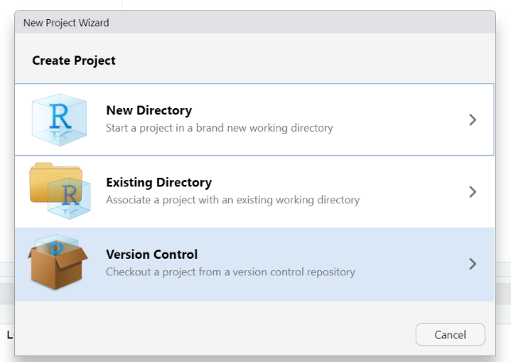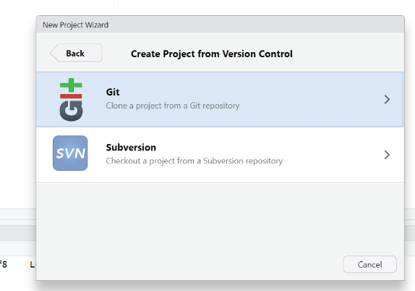
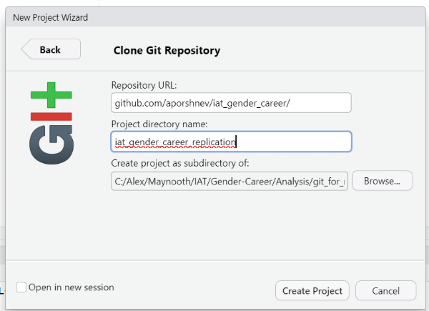
- Extract from in_Distances.zip: folders in_Distances and in_Control into main project folder
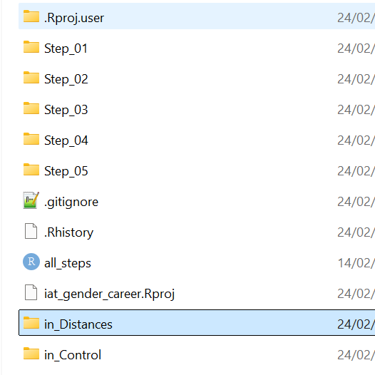

For steps 3-5.

- To run steps 3-5 (comment 25-29 lines)
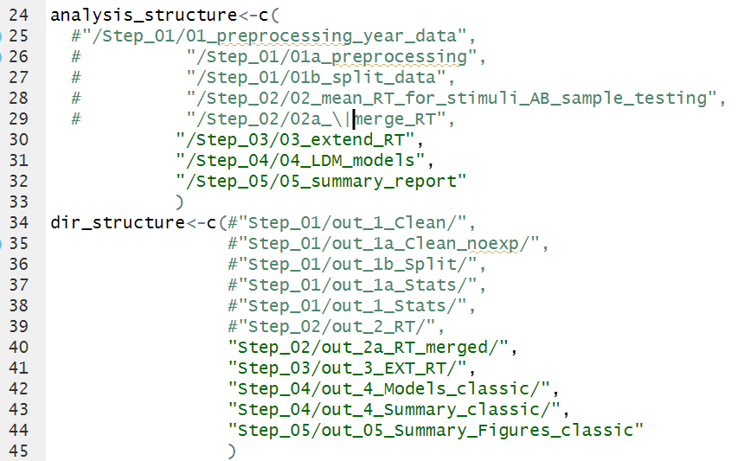
- Copy data from zip folder- out_2a_RT_merged.zip to Step_02\out_2a_RT_merged\
- Run all_steps.R script – it should generate html reports in each folder and additional files in folders (like figures, summary tables, etc.)
e.g.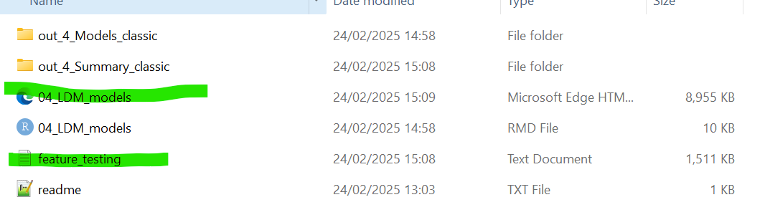
NOTICE: Render for Step 3 and Step 5 are quite quick, but Step 4 can take about an hour.

For whole sequence 1-5
- Extract from in_RAW_IAT_data_(1000).zip: folders into in_RAW_IAT_data at root project folder (it will work only with small subsample, so preprocessing would take too much time)
- Check that there are no comments in 24-45 lines)
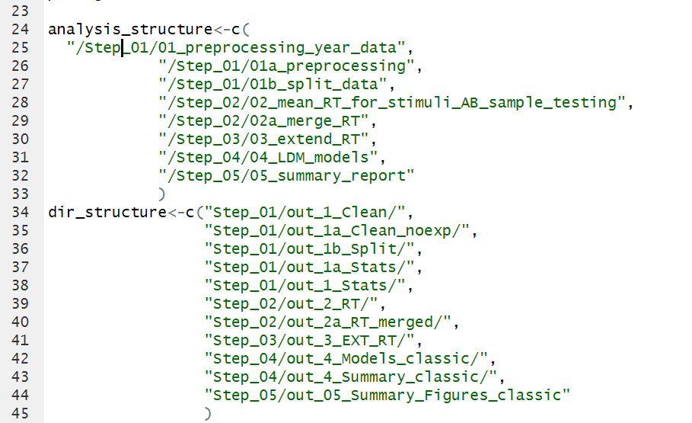
- Run all_steps.R script – it should generate html reports in each folder and additional files in folders (like figures, summary tables, etc.) e.g.

